***CIS 311 - Assignment 1***

This first assignment is going to require you to call upon pretty much everything you learned in CS 146 and to put that knowledge to work. You will be creating an inventory system for an IT department that keeps track of the various specifications of computers. Specifically you will track the manufacturer, form (desktop, notebook, tablet), processor, RAM, hard drive capacity, video set, amount of Video RAM and whether or not the device has a wireless connection. Here’s a screen showing one of the inventory items:

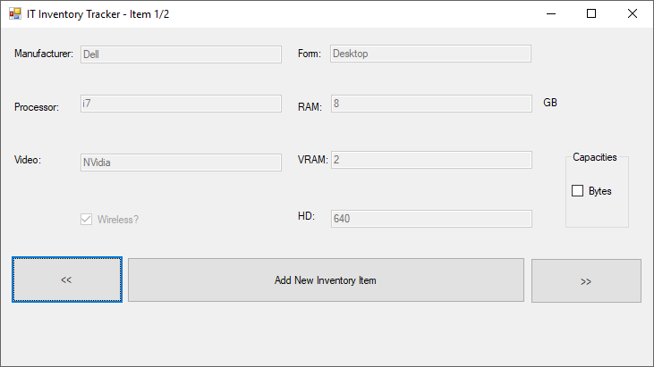

Notice that the title bar shows how many items are available and which item you are currently looking at. All input is “locked down” in the view mode and you can transition from record to record by using the << and >> buttons. At any point in time, a user may click the Bytes checkbox to convert all of the values from rounded GB values to actual bytes. If a user tries to move past the first record or the last record, an appropriate error message should appear:

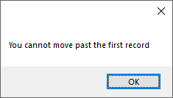

New items can be added to the system using the Add New Inventory Item button. When this appears, a blank form will show up allowing the user to enter information in about a new device. The record can either be saved or cancelled with the appropriate button clicks. The bytes checkbox is also fully functional here, but you should ensure that capacities are only entered and stored as rounded GB, not full bytes (however the full byte capacity can be calculated at any point).

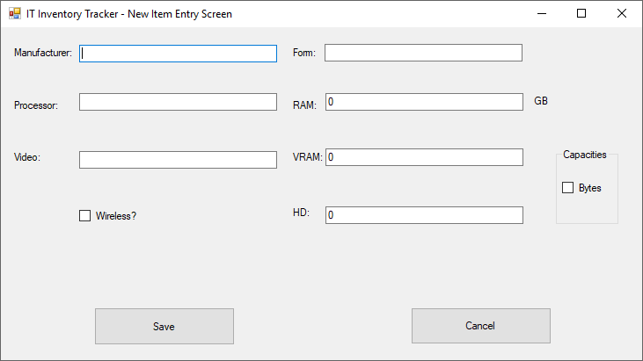

When you run the system for the first time, there will not be any items in the inventory system, so you should immediately force the user to enter a new inventory item device. While you may choose to hold the inventory items in memory using a backing store such as an array of structures, you will need to write the inventory items out to a file so that they are saved between subsequent program executions. You should place the text file in the same folder as your executable so there will be no pathing issues in the program. After you have created a text file with records, those values should be read in upon any future execution to bring the previous inventory items back into context so that the user can see them. Pay attention to the bytes to gigabyte conversion checkbox – it can be checked/unchecked at any time during record viewing or during adding of a new device and it should never blow your program up. Also, again remember that you will want to only save rounded gigabyte values out to memory and the backing store, never full byte capacity values. Good luck!

You will need to zip all of your project files (everything in the project folder and all folders/contents beneath it) and upload that to Canvas. You will also need to print and complete a program cover sheet and print screenshots of the program in execution – ***staple (buy a stapler if you don’t have one!!!!)***  those items together in that order and turn that in at the beginning of class on the due date. This will be standard practice for every assignment in this class, so make sure you do things correctly or I will deduct points.